## Overview

This document explains the policy/rule to share content on Facebook, specifically mentioning the permission on user time line and Facebook public pages

## 3M Water Dealer App Activities

**Implementation Done:**

* Like a Facebook Page
* Share on Facebook Page

**Share on Facebook Page :**

**Note**: Sharing on any Facebook public page via the iPad App can only be done if the authenticated user (Any Salesrep who is using the App and has his Facebook credentials login) has specific rights for that page that being of either admin, editor or moderator.

Email Ids for all the Salesrep need to be given any of the specific rights mentioned above on all the Facebook pages on which sharing is to be done from the iPad App.

* Authenticated User here means the user (salesrep) is authenticated on Facebook for the current app (3M Water Dealer iPad App) using his valid login credentials.

## Steps to Perform

Consider a Facebook Page below. Rights to be provided shown below:

* Navigate to Page “Settings”
* From the left options -> select “Page Roles”
* “Add Another Person” by his email id and assign the role to the salesrep (Admin, Editor OR Moderator)

* Following Steps need to be followed by Dealers for adding SalesRep on the Dealer Page as well as by 3M for adding Salesrep of all Dealers on 3M Water Dealer App Facebook Page.

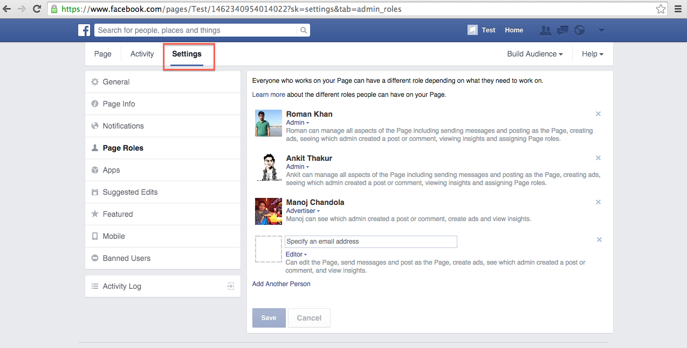

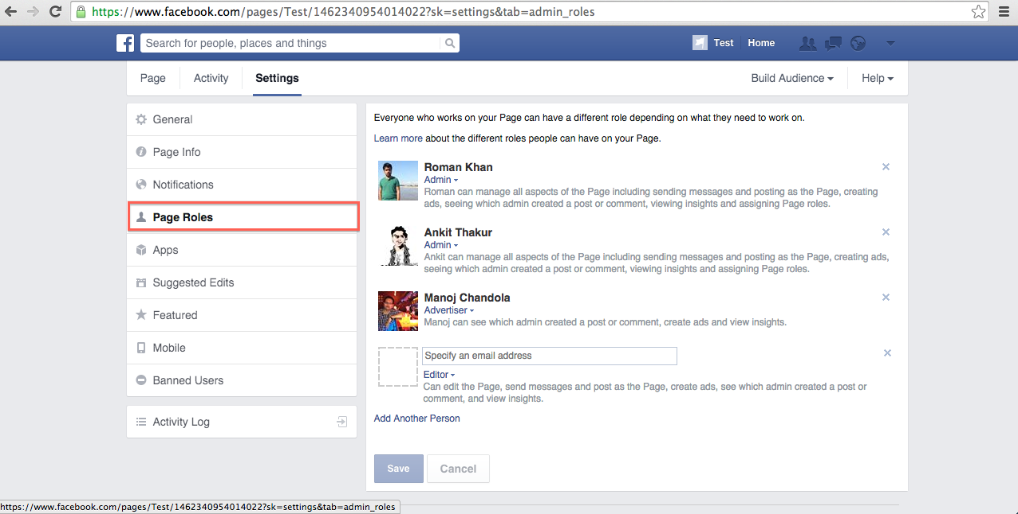

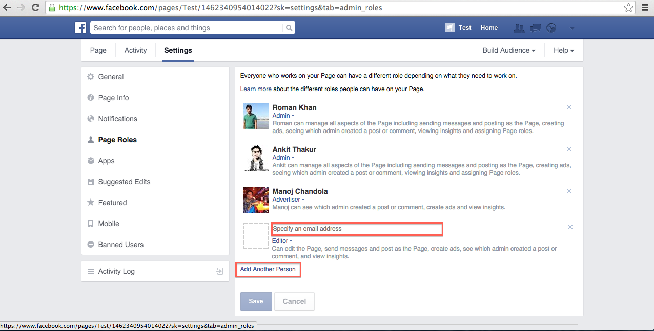

**Like on Facebook Page :**

Facebook does not provide the like page functionality through its iOS SDK or either Graph API, so liking the facebook page in 3M Water Dealer iPad App is done by opening the Page in Webview and hence authentication is to be done again.